**Report Writing**

**Data preparation:**

1. **Installing library packages and loading them:**

**Code:**

install.packages("ggplot2")

install.packages("dplyr")

install.packages("visdat")

install.packages("ROSE")

library(ggplot2)

library(dplyr)

library(visdat)

library(ROSE)

**Output:**

**Description:**

At first, all the necessary library packages were downloaded and loaded into R studio. libraries: ggplot2 for data visualization, dplyr for data manipulation, visdat for visualizing data structures, and ROSE for addressing imbalanced data.

1. **Reading/Loading the dataset:**

**Code:**

patientData<- read.csv("E:/caesarian/caesarian.csv",header=TRUE,sep=",")

patientData

**Output:**

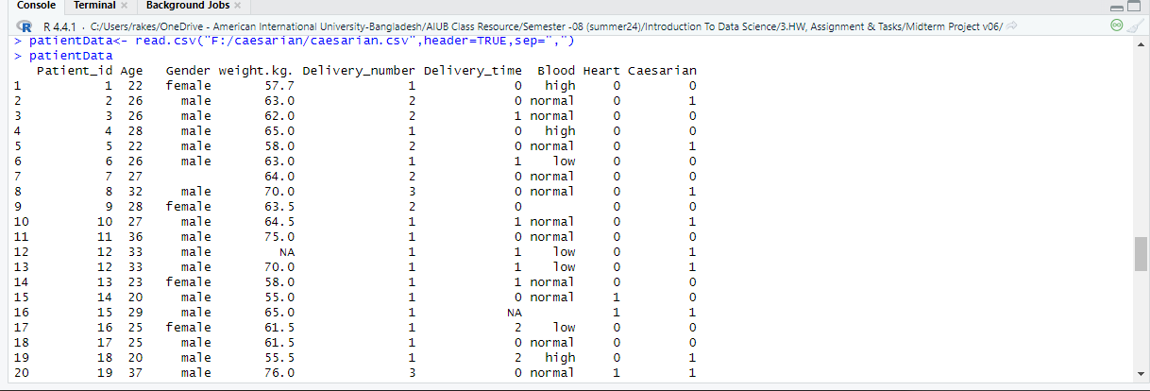

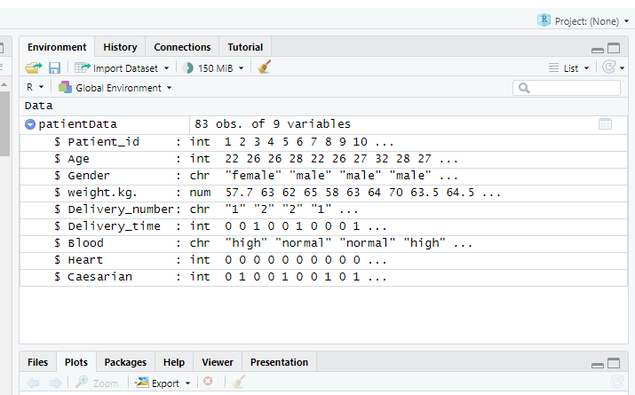

**Description:**

After loading the library, the dataset stored in a CSV file was imported into R studio using read.csv() method. The dataset is stored in a dataframe called “patientData”. Using the str() method, it was checked whether the dataset was successfully loaded or not.

1. **Inspecting the structure and summery of the data:**

**Code:**

caesarian_data <- patientData

str(caesarian_data)

summary(caesarian_data)

head(caesarian_data)

**Output:**

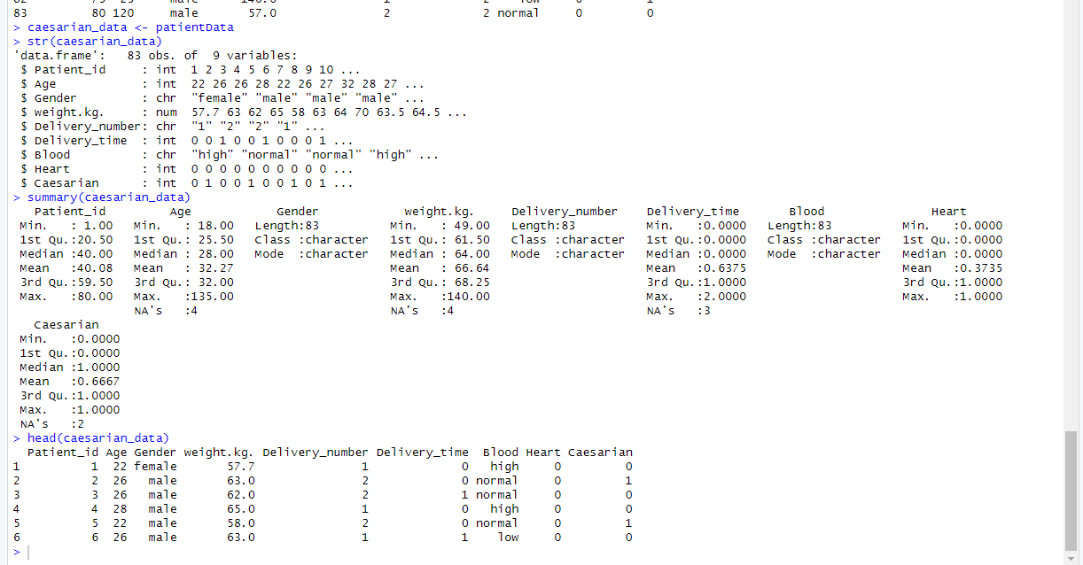

**Description:**

First, a copy of patientData was made in caesarian_data dataframe. The stl() displayed the data types of each column, the summary() slowed the min,max,mean,median,1st Quadrant, 3rd Quadrant, no of NA values, the head() printed the first 6 rows of the dataset.

1. **Checking unique values for the catagorical entities to find invalid entries:**

**Code:**

unique(caesarian_data$Gender)

unique(caesarian_data$Blood)

unique(caesarian_data$Delivery_number)

**Output:**

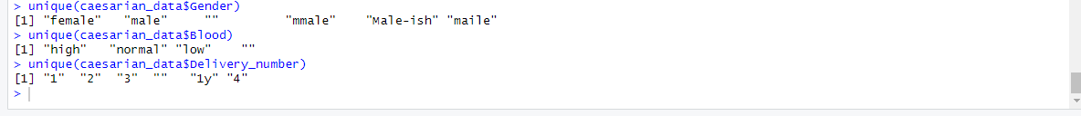

**Description:**

Checking for unique values to identify potential invalid entries in categorical type columns Gender, Blood, and Delivery_number.

1. **Defining & replacing invalid values:**

**Code:**

valid_genders <- c("male", "female")

valid_delivery_number <- c("1", "2", "3", "4")

replace_invalid <- function(value, valid_values, replacement = NA) {

if (value %in% valid_values) {

return(value)

} else {

return(replacement)

}

}

caesarian_data$Gender<-sapply(caesarian_data$Gender,replace_invalid,valid_genders)

caesarian_data$Delivery_number<-sapply(caesarian_data$Delivery_number, replace_invalid, valid_delivery_number)

unique(caesarian_data$Gender)

unique(caesarian_data$Delivery_number)

**Output:**

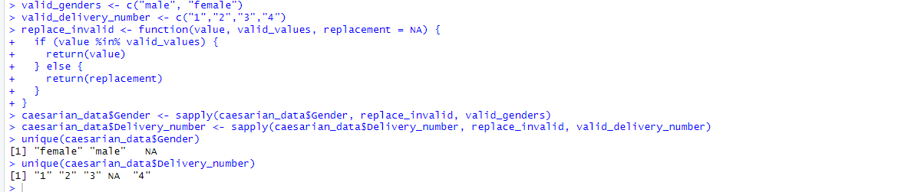

**Description:**

Now, valid values of gender and delivery_number column was defined in vertor data type. A function named replace_invalid was made. The function takes value, valid_value and replacement = NA as its parameter and checks weather the value is in valid_value or not. For valid, the value remains the same and if found invalid, it is replaced with the replacement value (NA). The function is applied to replace invalid values using sapply(). The sapply() function takes a list, vector, or data frame as input and gives output in the form of an array or matrix object. Optionally, the data was inspected to see weather the replacement was successful or not.

1. **Type conversion of data to numerical type:**

**Code:**

caesarian_data$Delivery_number <- as.integer(caesarian_data$Delivery_number)

caesarian_data$Gender <- factor(caesarian_data$Gender,

levels = c("male", "female"),

labels = c(0, 1))

caesarian_data$Blood <- factor(caesarian_data$Blood,

levels = c("low", "normal", "high"),

labels = c(0, 1, 2))

str(caesarian_data)

**Output**:

**Description**: Then, by modifying the factor data structures, Delivery_number and Blood column was converted to factor type to make the numerical. Factors are categorical variables that can only take a predefined set of values. In the factor() function, the level specifies the valid levels or categories for the factor variable, where the labels assigns numerical codes to each level. By using the <- as.integer() function, delivery_number column was converted to a numerical type. Optionally, the structure of the dataset was checked using str() to ensure successful conversion.

1. **Calculating & displaying Q1, Q3, and IQR:**

**Code:**

Q1_age <- quantile(caesarian_data$Age, 0.25, na.rm = TRUE)

Q3_age <- quantile(caesarian_data$Age, 0.75, na.rm = TRUE)

IQR_age <- Q3_age - Q1_age

Q1_weight <- quantile(caesarian_data$weight.kg., 0.25, na.rm = TRUE)

Q3_weight <- quantile(caesarian_data$weight.kg., 0.75, na.rm = TRUE)

IQR_weight <- Q3_weight - Q1_weight

Q1_age

Q3_age

IQR_age

Q1_weight

Q3_weight

IQR_weight

**Output:**

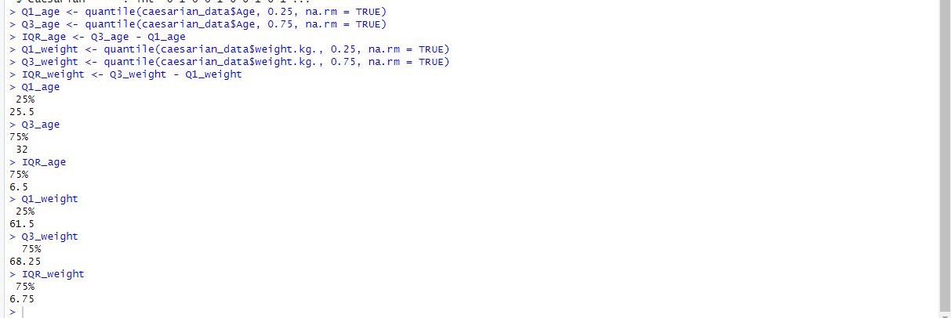

**Description:**

Q1 (1st Quartile): The 25th percentile value, indicating that 25% of the data points are below this value.

Q3 (3rd Quartile): The 75th percentile value, indicating that 75% of the data points are below this value.

IQR (Interquartile Range): The difference between Q3 and Q1, representing the spread of the middle 50% of the data.

Here, quantile() function was used to calculate Q1 and Q3. Then using them IQR was measured and them all three are displayed.

1. **Identifying outliers and plotting boxplot:**

**Code:**

detect_outliers <- function(x, Q1, Q3, IQR) {

lower_bound <- Q1 - 1.5 * IQR

upper_bound <- Q3 + 1.5 * IQR

return(x < lower_bound | x > upper_bound)

}

age_outliers <- detect_outliers(caesarian_data$Age, Q1_age, Q3_age, IQR_age)

weight_outliers <- detect_outliers(caesarian_data$weight.kg., Q1_weight, Q3_weight, IQR_weight)

ggplot(caesarian_data, aes(y = "", x = Age)) +

geom_boxplot(fill = "lightblue") +

ggtitle("Boxplot of Age with Outliers") +

theme_minimal() +

labs(x = "Age", y = "")

ggplot(caesarian_data, aes(y = "", x = weight.kg.)) +

geom_boxplot(fill = "lightgreen") +

ggtitle("Boxplot of Weight (kg) with Outliers") +

theme_minimal() +

labs(x = "Weight (kg)", y = "")

**Output:**

**Description:**

Here, detect_outliers function identifies outliers in a numeric vector called x using the interquartile range (IQR) method. Using the function then outliers for age, weight column was identified and then using ggplot function the boxplot was formed. ggplot() function has different types of features to plot and visualize data like geom_boxplot Adds a boxplot layer to the plot, ggtitle sets the plot’s title, theme_minimal() removes background grid lines and clutter, labs() labels x and y axis.

1. **Handling outliers:**

**Code:**

cap_outliers <- function(x, Q1, Q3, IQR) {

lower_bound <- Q1 - 1.5 * IQR

upper_bound <- Q3 + 1.5 * IQR

x[x < lower_bound] <- lower_bound

x[x > upper_bound] <- upper_bound

return(x)

}

caesarian_data$Age <- cap_outliers(caesarian_data$Age, Q1_age, Q3_age, IQR_age)

caesarian_data$weight.kg. <- cap_outliers(caesarian_data$weight.kg., Q1_weight, Q3_weight, IQR_weight)

ggplot(caesarian_data, aes(y = "", x = Age)) +

geom_boxplot(fill = "lightblue") +

ggtitle("Boxplot of Age After Handling Outliers") +

theme_minimal() +

labs(x = "Age", y = "")

ggplot(caesarian_data, aes(y = "", x = weight.kg.)) +

geom_boxplot(fill = "lightgreen") +

ggtitle("Boxplot of Weight (kg) After Handling Outliers") +

theme_minimal() +

labs(x = "Weight (kg)", y = "")

**Output:**

**Description:**

A function called cap_outliers was formed to handle outliers and using it outliers were handled for age and weight column. Then the boxplot was generated again to check whether outlier handling was successful or not.

1. **Checking for missing values:**

**Code:**

missing_values <- colSums(is.na(caesarian_data))

print(missing_values)

**Output:**



**Description:**

By using is.na() function the presence of missing values were detected and using colSums() function the sum was calculated and displayed.

1. **Visualizing missing values:**

**Code:**

vis_miss(missing_values)

**Output:**

**Description:**

By using vis_miss() function the Visualization of missing values was achieved.

1. **Removing missing values:**

**Code:**

caesarian_data$Age[is.na(caesarian_data$Age)] <- round(median(caesarian_data$Age, na.rm = TRUE))

caesarian_data$weight.kg.[is.na(caesarian_data$weight.kg.)]<-mean(caesarian_data$weight.kg., na.rm = TRUE)

mode_impute <- function(x) {

uniq_x <- na.omit(unique(x))

freq_x <- table(x)

return(names(freq_x)[which.max(freq_x)])

}

caesarian_data$Gender[is.na(caesarian_data$Gender)]<-mode_impute(caesarian_data$Gender)

caesarian_data$Delivery_number[is.na(caesarian_data$Delivery_number)]<- mode_impute(caesarian_data$Delivery_number)

caesarian_data$Delivery_time[is.na(caesarian_data$Delivery_time)]<- mode_impute(caesarian_data$Delivery_time)

caesarian_data$Blood[is.na(caesarian_data$Blood)]<- mode_impute(caesarian_data$Blood)

caesarian_data <- na.omit(caesarian_data)

vis_miss(caesarian_data)

**Output:**

**Description:**

For Numerical Columns like Age and weight column, missing values were imputed with median or mean. For Categorical Columns like Gender, Delivery_number, Delivery_time, and Blood, the mode imputation function was constructed, and missing values were removed using the function. Then, rows with any remaining missing values were removed using the na.omit() function. Finally, using the vis_miss(), present of missing values were visualized.

1. **Removing duplicates in rows:**

**Code:**

caesarian_data<-distinct(caesarian_data)

caesarian_data<-distinct(caesarian_data,Patient_id, .keep_all = TRUE)

caesarian_data

**Output:**

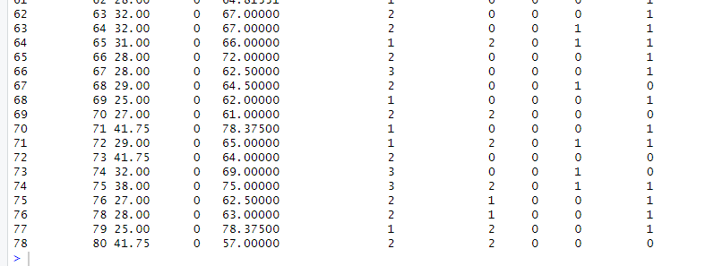

**Description:**

Using distinct() function. Duplicates were removed. Then by calling the caesarian_data it was checked whether duplicate values were removed or not.

1. **Perform & checking oversampling, undersampling, balanced sampling data:**

**Code:**

oversampled_data <- ovun.sample(Caesarian ~ ., data = caesarian_data, method = "over", p = 0.5, seed = 1)$data

table(oversampled_data$Caesarian)

undersampled_data <- ovun.sample(Caesarian ~ ., data = caesarian_data, method = "under", p = 0.5, seed = 1)$data

table(undersampled_data$Caesarian)

balanced_data <- ovun.sample(Caesarian ~ ., data = caesarian_data, method = "both", p = 0.5, seed = 1)$data

table(balanced_data$Caesarian)

**Output:**

**Description:**

The oversampling and under sampling on gender column was done and then the dataset was balanced and checked afterwards. Here, the ovun.sample function from the ROSE package performs oversampling and undersampling, with the method = "both" option combines oversampling and undersampling techniques to balance the data.

1. **Filter the dataset:**

**Code:**

filtered_data <- caesarian_data %>% filter(Gender == 1)

filtered_data

**Output:**

**Description:**

The given dataset is about caesarian section results of pregnant women. Thus, the dataset is exclusively for female patients not male. So, the filter method was applied on the caesarian_data and then stored in a new dataframe called filtered_data. Then, the dataframe was displayed to see the outcome.

1. **Calculating mean, median, and mode:**

**Code:**

mean_age <- mean(caesarian_data$Age, na.rm = TRUE)

median_age <- median(caesarian_data$Age, na.rm = TRUE)

get_mode <- function(v) {

uniqv <- unique(v)

uniqv[which.max(tabulate(match(v, uniqv)))]

}

mode_age <- get_mode(caesarian_data$Age)

stats_df <- data.frame(

Statistic = c("Mean", "Median", "Mode"),

Value = c(mean_age, median_age, mode_age)

)

ggplot(stats_df, aes(x = Statistic, y = Value, fill = Statistic)) +

geom_bar(stat = "identity") +

geom_text(aes(label = round(Value, 2)), vjust = -0.6) +

labs(title = "Mean, Median, and Mode of Age",

x = "Statistic",

y = "Value") +

theme_minimal() +

scale_fill_manual(values = c("blue", "green", "red"))

**Output:**

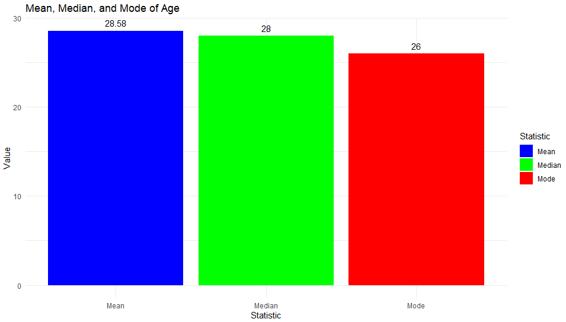

**Description:**

Here, mean() and median() function was used to calculate the mean and median, and the na.rm = TRUE argument was used to remove any missing values before calculation. get_mode() function identifies unique values in the data, then count occurrences using tabulate() then returns value with max count. stats_df is a created dataframe and ggplot2 with geom_bar() creates a bar graph.

1. **Age Distribution with mean, median and mode:**

**Code:**

plot_mean <- ggplot(caesarian_data, aes(x = Age)) +

geom_histogram(binwidth = 1, fill = "blue", alpha = 0.7) +

geom_vline(aes(xintercept = mean_age), color = "red", linetype = "solid", size = 1) +

ggtitle("Age Distribution with Mean") + theme_minimal() +

labs(x = "Age", y = "Frequency") + annotate("text", x = mean_age, y = Inf, label = paste("Mean:", round(mean_age, 2)), color = "red", vjust = 2)

plot_median <- ggplot(caesarian_data, aes(x = Age)) +

geom_histogram(binwidth = 1, fill = "blue", alpha = 0.7) +

geom_vline(aes(xintercept = median_age), color = "green", linetype = "solid", size = 1) +

ggtitle("Age Distribution with Median") + theme_minimal() + labs(x = "Age", y = "Frequency") + annotate("text", x = median_age, y = Inf, label = paste("Median:", round(median_age, 2)), color = "green", vjust = 2)

plot_mode <- ggplot(caesarian_data, aes(x = Age)) +

geom_histogram(binwidth = 1, fill = "blue", alpha = 0.7) +

geom_vline(aes(xintercept = mode_age), color = "purple", linetype = "solid", size = 1) +

ggtitle("Age Distribution with Mode") + theme_minimal() + labs(x = "Age", y = "Frequency") + annotate("text", x = mode_age, y = Inf, label = paste("Mode:", round(mode_age, 2)), color = "purple", vjust = 2)

plot_mean

plot_median

plot_mode

**Output:**

**Description:**

Here, plot_mode, plot_median and plot_mode was created and then called to display mean, median and mode. The geom_histogram() creates a histogram, geom_vline() adds vertical line, and annotates values of mean, median and mode on the top of histogram.

1. **Summary statistics for Age:**

**Code:**

summary(caesarian_data$Age)

**Output:**



**Description:**

To summarize the Age variable in the caesarian_data dataset,the summery() function is used here. Here,

Min: Minimum age in the dataset.

1st Qu.: First quartile (25th percentile).

Median: Middle value (50th percentile).

Mean: Average age.

3rd Qu.: Third quartile (75th percentile).

Max: Maximum age in the dataset.

1. **Min-Max Normalization:**

**Code:**

normalize <- function(x) {

return((x - min(x)) / (max(x) - min(x)))

}

caesarian_data$Age_normalized <- normalize(caesarian_data$Age)

head(caesarian_data)

**Output:**

**Description:**

A function called normalize is made and using it the age column is normalized and then displayed. This function normalizes a numeric vector x to a range between 0 and 1 by using the following formula: Normailized value = x min(x) / max(x) – min(X). Then the normalized function is called to normalize the Age column of the caesarian_data dataset and then the result is stored in Age_normalized. The head() function is called to show the first six rows of the dataset of Age_normalized column.

1. **Displaying the structure of the cleaned dataset:**

**Code:**

str(caesarian_data)

**Output:**

**Description:**

Finally, the str() is used here to see the structure of the dataset at the ending.

1. **Showing the cleaned dataset:**

**Code**

caesarian_data

**Output:**

**Description:**

Finally, by simply writing down caesarian_data, the final version of the cleaned data dataset is viewed to see and observe the result.